**Assignment -4**

Python Programming

| Assignment Date | 19 September 2022 |
| --- | --- |
| Student Name | Shambavi P |
| Maximum Marks | 2 Marks |

**Problem Statement:**

Over recent years, as the popularity of mobile phone devices has increased, Short Message Service (SMS) has grown into a multi-billion-dollar industry. At the same time, reduction in the cost of messaging services has resulted in growth in unsolicited commercial advertisements (spams) being sent to mobile phones. Due to Spam SMS, Mobile service providers suffer from some sort of financial problems as well as it reduces calling time for users. Unfortunately, if the user accesses such Spam SMS they may face the problem of virus or malware. When SMS arrives at mobile it will disturb mobile user privacy and concentration. It may lead to frustration for the user. So Spam SMS is one of the major issues in the wireless communication world and it grows day by day.

**Question-1:**

Download the dataset: Dataset

**Solution:**

https://www.kaggle.com/code/kredy10/simple-lstm-for-text-classification/data

**Question-2:**

Import required library

**Solution:**

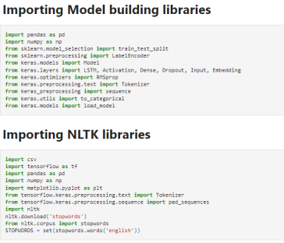**Question-3:**

Read dataset and do pre-processing

**Solution:**

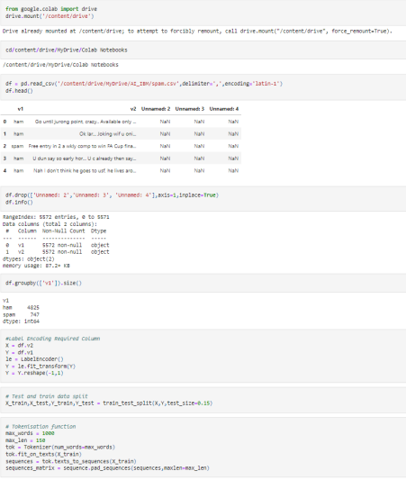**Question-4:**

**Add Layers (LSTM, Dense-(Hidden Layers), Output)**

**Solution:**

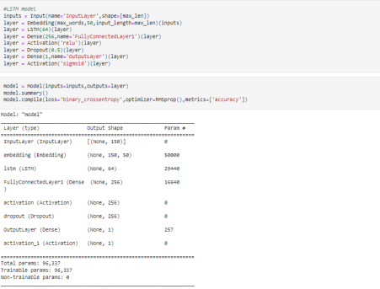

**Question-5:**

**Compile The Model**

**Solution:**

**Question-6:**

**Fit The Model**

**Solution:**

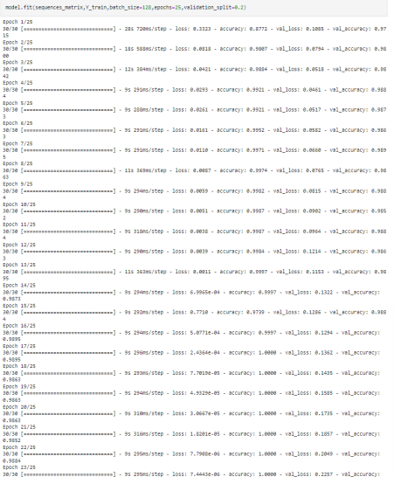

**Question-7:**

**Save The Model**

**Solution:**



**Question-8:**

**Test The Model**

**Solution:**

